NAME: | Ameya Dabholkar
UID: | 2021300023
SUBJECT | Design and Analysis of Algorithm
EXPERIMENT NO : | 04
DATE OF PERFORMANCE | 05/03/2023
DATE OF SUBMISSION | 12/03/2023
AIM: | To find the minimum matrix chain multiplications required.
PROBLEM STATEMENT 1: | Matrix chain multiplication of matrices of different order.
ALGORITHM and THEORY: | MATRIX-CHAIN-ORDER (p)  - n length[p]-1  - for i ← 1 to n  - do m [i, i] ← 0  - for l ← 2 to n // l is the chain length  - do for i ← 1 to n-l + 1  - do j ← i+ l -1  7. m[i,j] ← ∞  - for k ← i to j-1  - do q ← m [i, k] + m [k + 1, j] + pi-1 pk pj  - If q < m [i,j]  - then m [i,j] ← q  - s [i,j] ← k  - return m and s.

PROGRAM: | #include<stdio.h> #include<math.h> #include<limits.h>  int MCM(int a[],int i,int j)  {  if(i==j)  {  return 0;  }  int k;  int min=INT_MAX; int count; for(k=i;k<j;k++)  {  count=MCM(a,i,k)+MCM(a,k+1,j)+a[i-1]*a[k]*a[j]; if(count<min)  {  min=count;  }  }  return min;  }  int main()  {  int n,i,j;  printf("Enter the size of the array: "); scanf("%d",&n);  int a[n]; for(i=0;i<n;i++)  {  a[i]=rand()%50;  }  printf("Array: "); for(i=0;i<n;i++)

{
printf("%d ",a[i]);
}
int N=sizeof(a)/sizeof(a[0]);
printf("\nMinimum number of multiplications is %d.\n",MCM(a,1,n- 1));
return 0;
}
OUTPUT: | 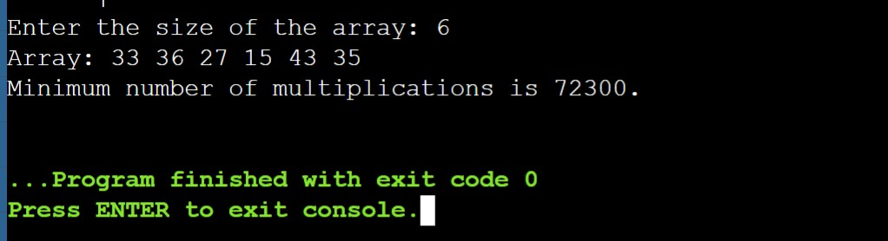  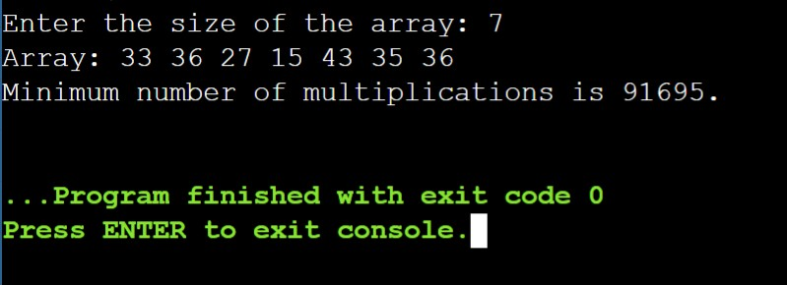
CONCLUSION: | By performing above experiment I have understood matrix chain multiplication and its uses thoroughly. This dynamic programming approach reduces time complexity of the matrix chain multiplication.

